

Dharmsinh Desai University, Nadiad

Faculty of Technology, Department of Computer Engineering

B.Tech. CE Semester – VI

Subject: (CE-620) OBJECT ORIENTED SOFTWARE ENGG.

Project Title:

Exam Portal

By:

Jaimin Chauhan (roll no: CE018 id: 17CEUBS084)

Aatish Chaudahri (roll no: CE003 id: 17CEUBN031)

Guided By:

Prof. Prashant Jadav



Dharmsinh Desai University, Nadiad

Faculty of Technology, Department of Computer Engineering

**CERTIFICATE**

This is to certify that Object Oriented Software Engg. project entitled “Exam Portal” is the bonafied report of work carried out by

1. **Jaimin Chauhan (17CEUBS084 )**
2. **Aatish Chaudahri (17CEUBN031)**

Of Department of Computer Engineering, Semester VI, academic year 2019-20, under your supervision and guidance.

|  |  |  |
| --- | --- | --- |
| Guide |  | HOD |
|  |  |  |
| **Prof. Prashant Jadav** |  | **Dr. C. K. Bhensdadia** |
| Associate Professor of |  | Head of the Department of |
| Department of Computer |  | Department of Computer |
| Engineering, Dharmsinh Desai University, Nadiad. |  | Engineering, Dharmsinh Desai University, Nadiad. |

Table of Contents

1.Abstract...…………………………..…………………..……………………………………..…4

2 Introduction……………………………………………………………………….….................5 2.1 Project Details: Brief Introduction …………………...............................................................5 2.2 Technology and Tools Used .....................................................................................................6

3 Software Requirement Specifications ………………………...……………………………...…7 3.1 Scope ………………………………………………………...………………………………..7 3.2 System Functional Requirements ……………….…………………………………………...7 3.3Other-Non‐FunctionalRequirements................................................……………………….....8

4.Design...…………….……….……………………….……………………………..…………..94.1Use-Case-Diagram………………..……………....…………………………..…………...9 4.2Class-Diagram……………..….………………………...….……………………..………….10 4.3Sequnece-Diagram……………………..………………………………………..……..……..10 4.4ActivityDiagram………………………….…………………………………………..………11 4.5 E-R Diagram ………….………………………………………………..………………..…..14 4.6 data Dictionary……..…………………………………………………………………...…...14

5 Implementation Details ……………………………….……………………………….…...…15 5.1Modules …………………………………..…………………………………………….…...15 5.2 Functional prototypes ……………………………………………………………………….17

6 Testing ………………………………………………………………………………………...20 6.1 Testing Method….………………………………….……………………………....……….20 6.4 Test Cases …………………….……………………………………………………….....….20

7.Screen-shots of the System ……….…………………………………………......……..……...21

8.Conclusion ……………………………………………………………………….…...……….23

9.Limitations and Future Extensions of System ……………………………………………...…24

10 .Bibliography ...…………………………………………………….……………………..….24

1. Abstract

The purpose of on-line test simulator is to take online test in an efficient manner and no time wasting for checking the paper. The main objective of on-line test simulator is to efficiently evaluate the candidate thoroughly through a fully automated system that not only saves lot of time but also gives fast results.

2. Introduction

Online Examination System is technology-driven way to simplify examination activities like defining exam patterns with question bank, defining exam timer, objective/ subjective question sections, conducting exams using the computer or mobile devices in a paperless manner.

Online Examination System is a cost effective , scalable way to convert traditional pen and paper-based exams to online and paperless mode.

Candidates can appear for the exam using any desktop, laptop or mobile device with a browser. Exam results can be generated instantly for the objective type of questions.

You can conduct [Online Aptitude](https://onlineexamhelp.eklavvya.in/define-conduct-online-aptitude-test/) Tests to understand the problem-solving, reasoning ability of the individual.

Personality tests are suitable to know the nature of the person. Many multinational companies and institutes are using this method to select the right candidates.

You can also define the [online test series](https://onlineexamhelp.eklavvya.in/online-test-series/). It can be useful for the preparation of various competitive exams.

You can also conduct exams in [multiple languages](https://onlineexamhelp.eklavvya.in/can-conduct-online-exam-multiple-languages/). It is useful to eliminate the barrier of conducting online exams in English for rural areas.

If you wish to show exam questions and responses in 2 languages like English and Hindi then it can be configured easily in the system. Candidates preferring Hindi can select the Hindi option while the English Language can be chosen by students who want to appear for the online exam in English.

It is an efficient and cost-effective way to conduct online exams in multiple languages.

**2.2 Tools/Technologies Used**

**Technologies:**

ASP.NET MVC (Without any Scaffolding)

Entity Framework (6.x) for database

**Tools**

Visual Studio 2017

**Platforms**

http://localhost:15021

3. Software Requirement Specifications

**3.1 Product Scope**

It provide facility to Student to attend exam. It provide facility to Faculty that create exam paper and check it.

***Users:-***

1. Student
2. Faculty
3. Examination Head

***Description:-***

The University Exam portal is developed for handling the

activities for various users such as student, Faculty, Head of Department, Dean. Every teacher should have laptop with application installed.

***High level requirement:-***

***1.Student:-***

R1.1) Questions:-

Description:-Show Question to Student.

Input:-Student Answer.

Output:-At result time.

R1.1.1) Revisited:-

Description:-It indicate user to revisite the questions.

Input:-Student selection.

Output:-Alert

R1.1.2) Not Attempt:-

Description:-It indicate user that question is left.

Input:- ---

Output:-Alert

R1.1.3) Attempted:-

Description:-It indicate user that question is attempted.

Input:-Student input

Output:-Alert

R1.1.4) Remove:-

Description:-Faculty can Remove a question.

Input:-Faculty id,Password.

Output:-Conformation.

R1.2) Answer:-

Description:-Student can answer the question by selecting an option or By fill in the blank.

Input:-Student answer

Output:-Mark allocated according to answer

R1.2.1) Options:-

Description:-Add options to questions.

Input:-User enter options.

Output:-Conformation.

R1.2.2) Blanks:-

Description:-Add blank in question.

Input:- User enter Blanks.

Output:-Conformation.

R1.3) Exam Login:-

Description:-User can log in to exam.

R1.3.1)Student:-

Description:-Student can login.

Input:-Student id,Hall ticket code,Exam code.

Output:-Exam paper.

R1.4)View Result:-

Description:-Student can see his/her Result.

Input:-Student id,Password.

Output:-Result.

R1.5)View Schedule:-

Description:-Student can see his/her Exam schedule.

Input:-Student id,Password.

Output:-Schedule.

***2.Faculty***:-

R2.1) Exam Login:-

Description:-User can log in to exam.

R2.1.1)Faculty:-

Description:- Faculty can login.

Input:- Faculty id,password,Exam code.

Output:-Exam paper Editor.

R2.2) Exam Type:-

Description:-It describe the exam type.

R2.3.1) Internal:-

Description:-It is an internal type exam.

Input:-Questions,Time,Max. Marks.

R2.3.1) External:-

Description:-It is an External type exam.

Input:-Questions,Time,Max. Marks.

R2.3) Generate Result:-

Description:-It Make the exam result.

Input:-Student id,sem,Branch,Name.

Output:-Result data.

R2.4)Make Question:-

Description:-User can make a question.

Input:-Question,Marks,sem,branch.

Output:-Confirmation.

R2.5)Make Paper:-

Description:-User can make a paper by exsisiting questions.

Input:-Question.

Output:-Confirmation.

***3. Examination Head***

R3.1)Oraganize Exam:-

Description:-User can oraganize exam.

Input:-User Data.

Output:-Confirmation.

R3.1.1)Cancel Exam:-

Description:-User can Cancel an exam.

Input:-User Data.

Output:-Confirmation.

R3.1.2) Reschedule Exam:-

Description:-User can Reschedule an Exam.

Input:-User Data

Output:-Confirmation.

R3.2)Create Exam type:-

Description:-User can create exam type like Internal,External.

Input:-User can create a exam type.

Output:-Confirmation.

R3.3)Serach Exam:-

Description:-User can Serach a exam.

Input:-Seraching string.

Output:-Result.

**3.4 Other Nonfunctional Requirements**

**1. Performance**

The system must be interactive and the delays involved must be less. So in every action-response of the system, there are no immediate delays.

**2. Safety**

User details should be securely stored to the server. The main security concern is for user account hence proper login mechanism should be used to avoid hacking.

**3. Reliability**

As the system provides the right tools for discussion, problem solving it must be made sure that the system is reliable in its operations and for securing the sensitive details.

**4. Database**

System requires to access users data fast to maintain the performance.

4. Design

**4.1 Use Case Diagram**

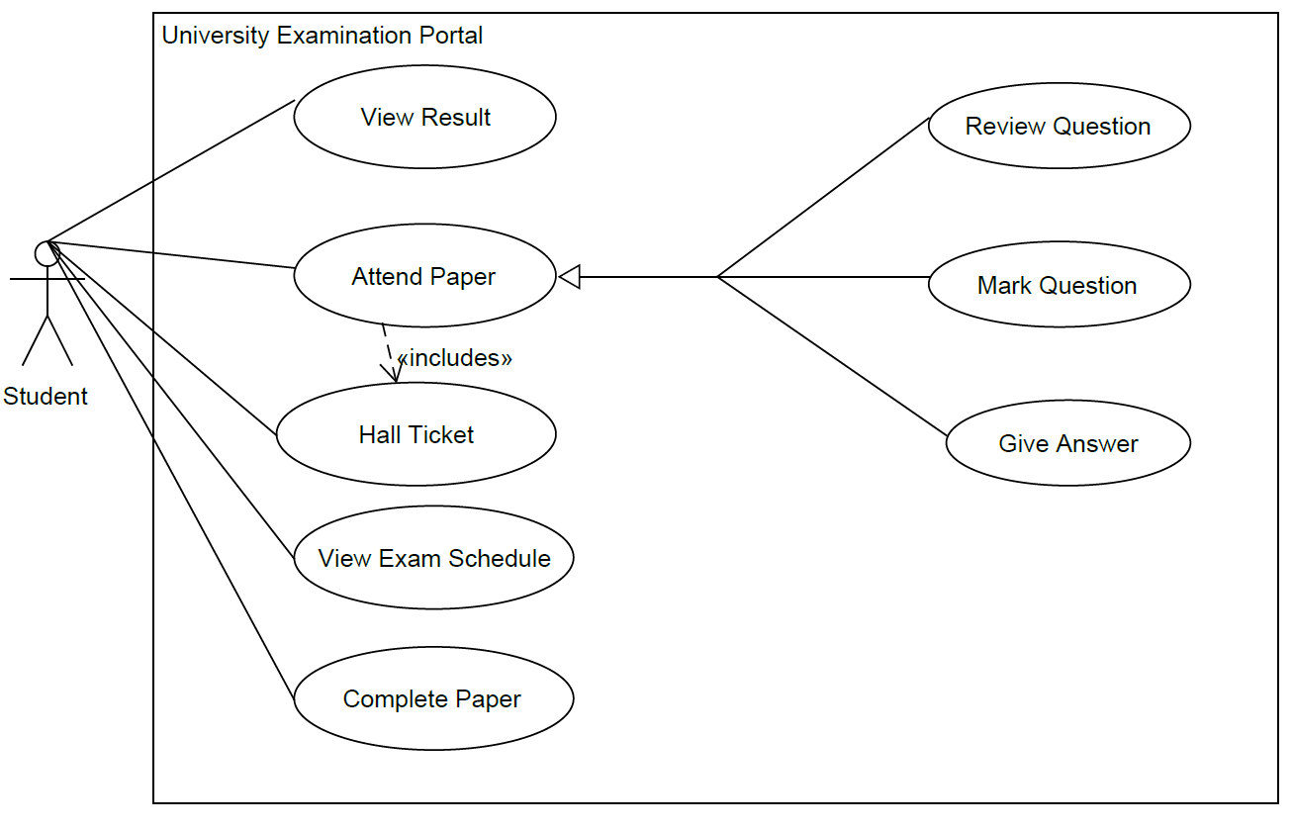

**4.2 Class Diagram**

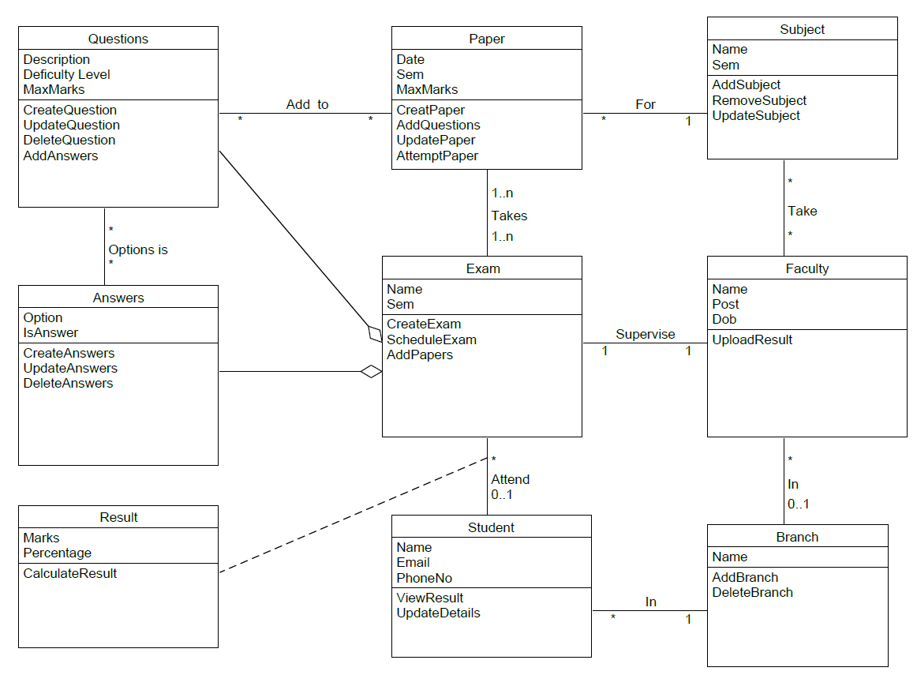

**4.3 Sequence Diagram**

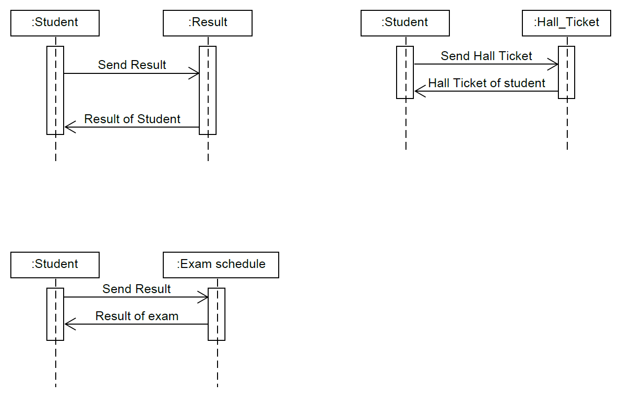

***Fig No:1. Sequence dia for 1.Result generation for student 2.Hall ticket generation for student 3.Exam Schedule for student***

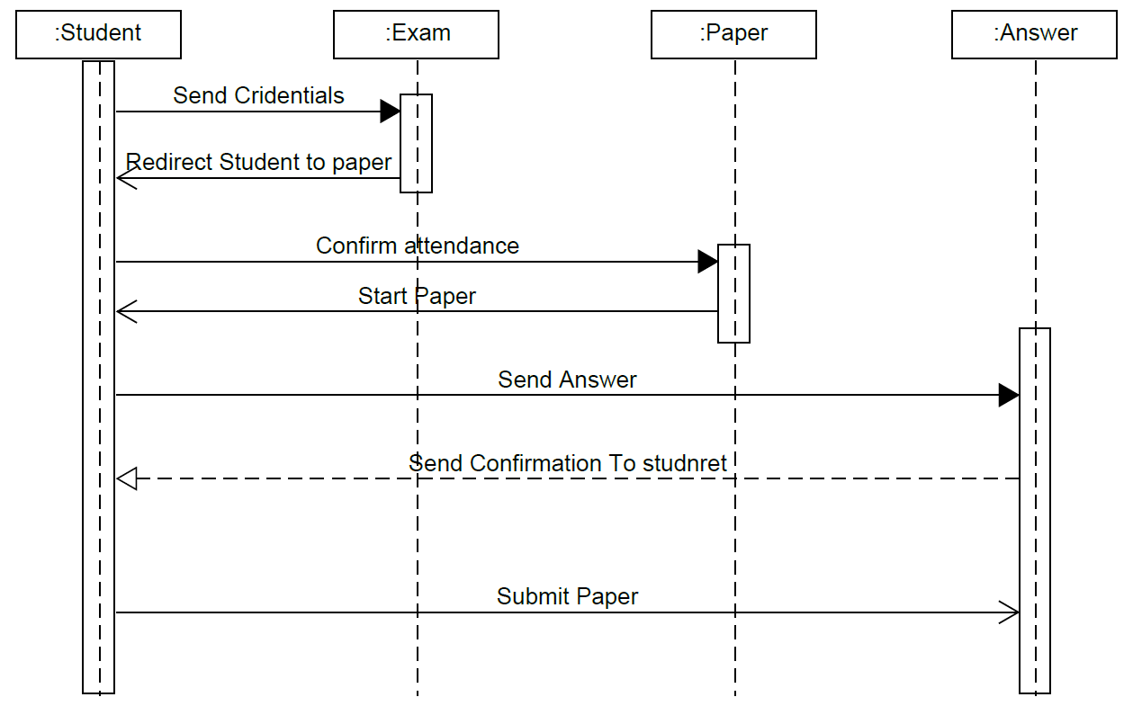

**Fig No:2. Sequence between Student, Exam, Paper and Answer Object in Project**

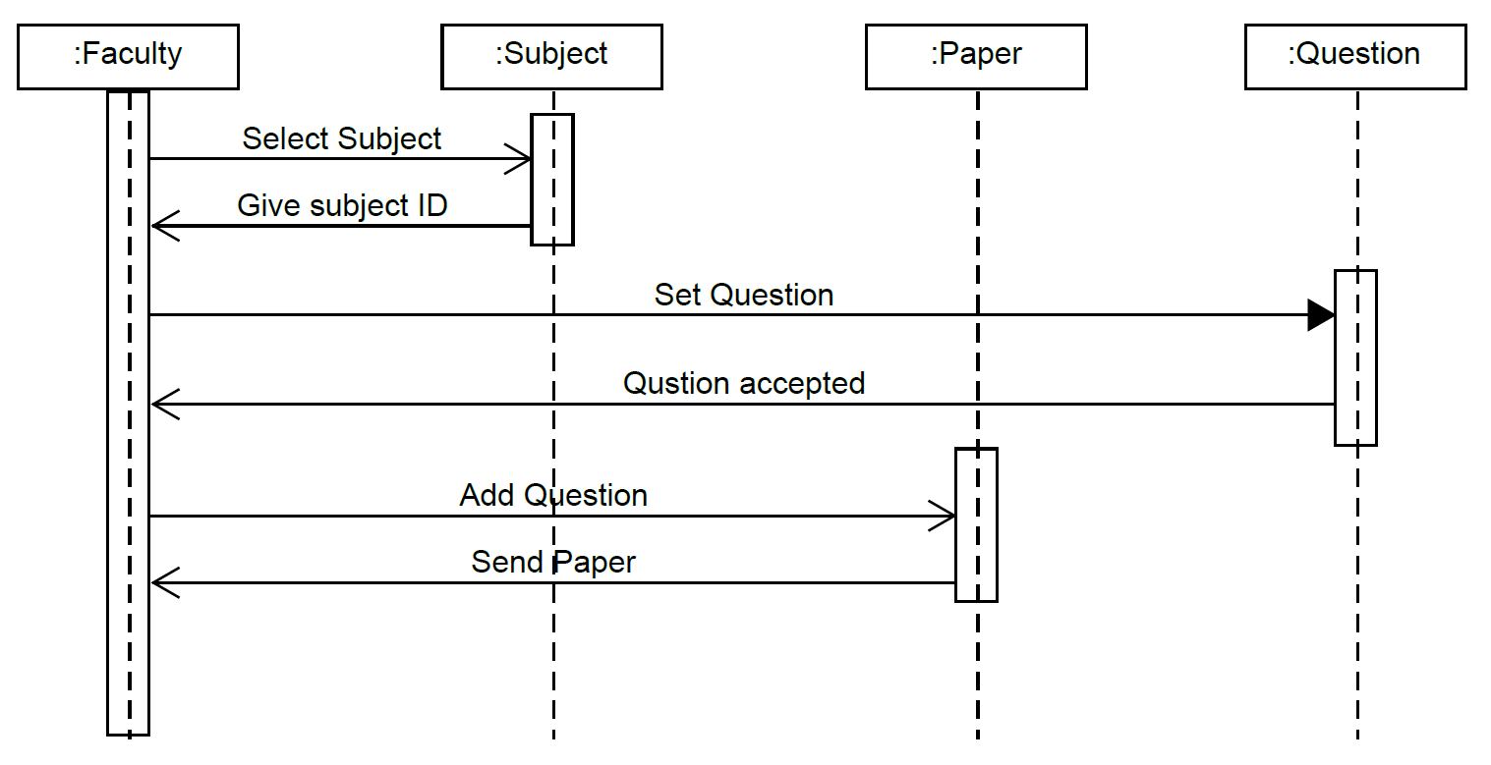

**Fig No:3. Sequence between Faculty, Subject, Paper and Question in Project**

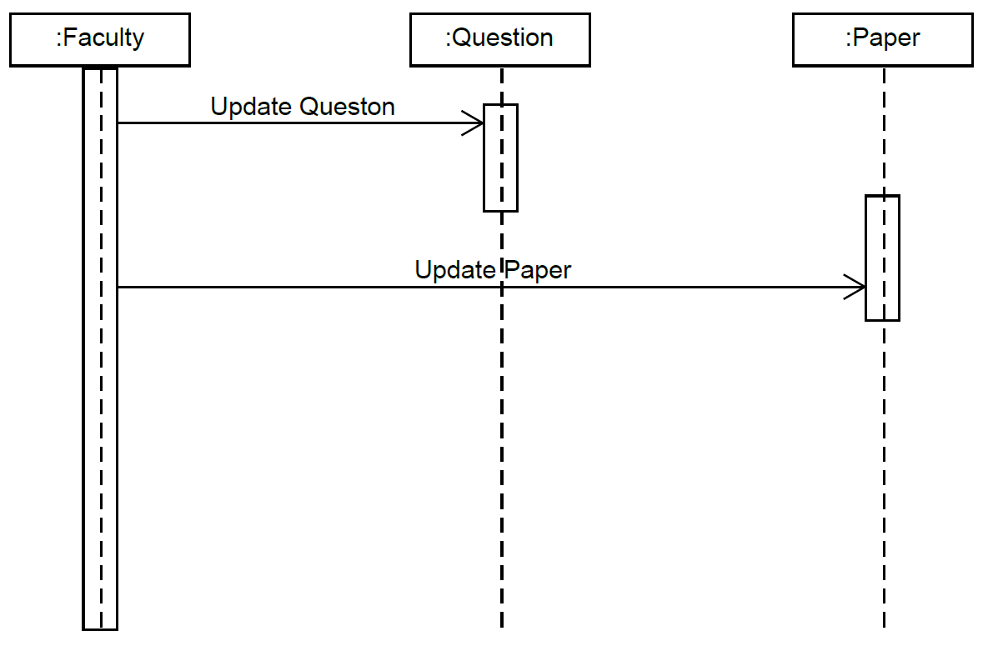

**Fig No:4. Sequence between Faculty, Question and Paper object in project**

**4.3 Activity Diagram**

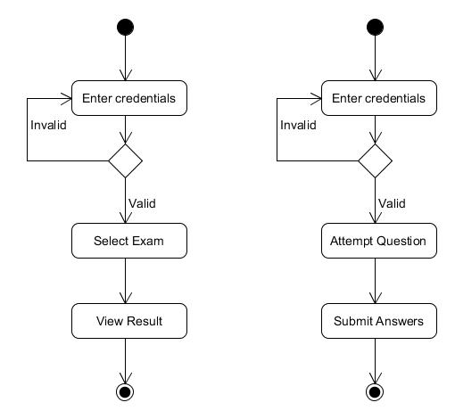

***Fig No:1. Activity for Checking credentials for Exam and Question for Student***

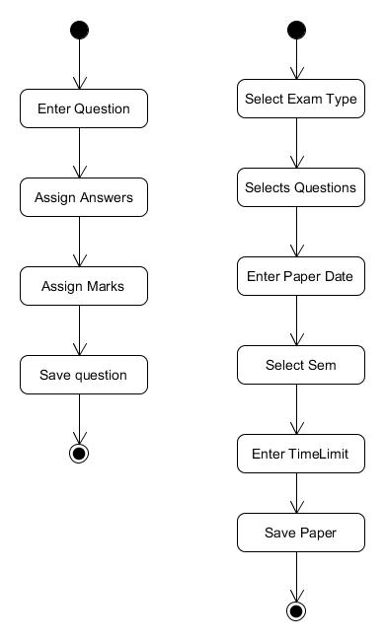

***Fig No:2. 1.Activity For adding a Question 2.Activity for Adding papers for Faculty***

**4.5 E-R Diagram**

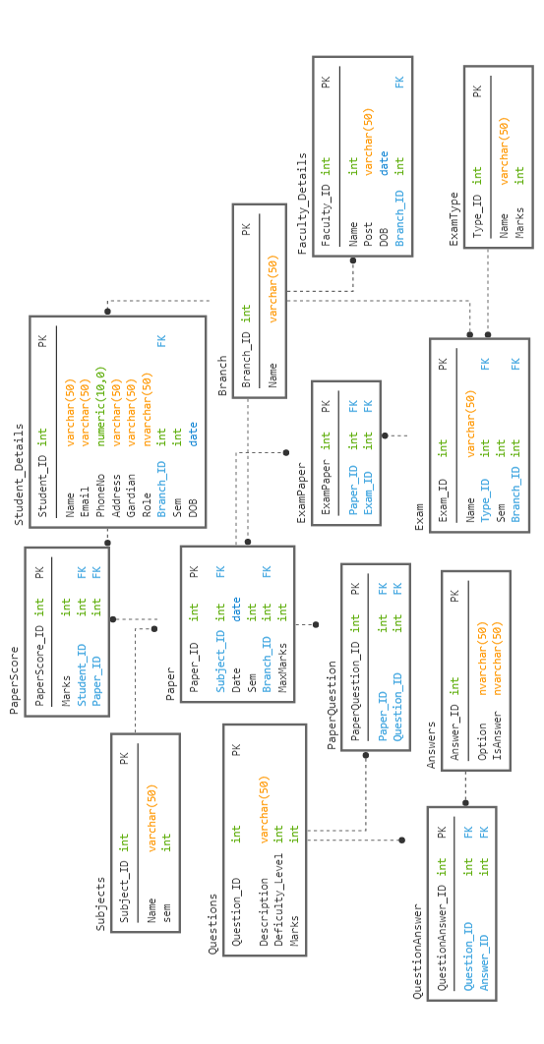

**4.6 Data Dictionary**

|  |  |  |  |  |  |  |  |  |
| --- | --- | --- | --- | --- | --- | --- | --- | --- |
| ***Student_Details*** | | | | | | | | |
| **Sr.No** | **Field name** | **Data Type** | **Width** | **Required** | **Unique** | **PK/FK** | **Referenced**  **Table** | **Description** |
| 1. | Student_ID | int | 10 | YES | YES | PK | - | Unique Id of user |
| 2. | Name | varchar | 50 | YES | NO | - | - | Name of User |
| 3. | Phone No. | Numaric | 10 | NO | NO | - | - | Phone no of user |
| 4. | Email | Email | 255 | YES | YES | - | - | Email of User |
| 5. | Gardian | varchar | 50 | NO | NO | - | - | Gadian of student |
| 6. | Role | varchr | 50 | YES | NO | - | - | Role of User |
| 7. | Branch_ID | Int |  |  |  | FK | Branch | Branch of Student |
| 8. | DOB | Date |  | Yes | No | - | - | Birth Date |

|  |  |  |  |  |  |  |  |  |  |
| --- | --- | --- | --- | --- | --- | --- | --- | --- | --- |
| ***Faculty_Details*** | | | | | | | | | |
| **Sr.No** | **Field name** | **Data Type** | **Width** | **Required** | **Unique** | **PK/FK** | **Referenced**  **Table** | **Description** |
| 1. | Faculty_ID | int | 10 | YES | YES | PK | - | Unique id of User |
| 2. | Name | varchar | 50 | YES | YES | - | - | Password of User |
| 3. | Post | Varchar | 50 | Yes | Yes |  |  |  |
| 4. | DOB | Date |  | Yes |  |  |  |  |

|  |  |  |  |  |  |  |  |  |
| --- | --- | --- | --- | --- | --- | --- | --- | --- |
| ***Questions*** | | | | | | | | |
| **Sr.No** | **Field name** | **Data Type** | **Width** | **Required** | **Unique** | **PK/FK** | **Referenced**  **Table** | **Description** |
| 1. | Question_ID | int | 10 | YES | YES | PK | - | Unique id of Question. |
| 2. | Discription | varchar | 255 | YES | NO | - | - | Question. |
| 3 | Difficulty Level | int | 10 | YES | NO | - | - | Level of a question. |
| 4. | Marks | Int | 10 | YES | NO | - | - | - |

|  |  |  |  |  |  |  |  |  |
| --- | --- | --- | --- | --- | --- | --- | --- | --- |
| ***Exam*** | | | | | | | | |
| **Sr.No** | **Field name** | **Data Type** | **Width** | **Required** | **Unique** | **PK/FK** | **Referenced**  **Table** | **Description** |
| 1. | Exam_ID | int | 10 | YES | YES | PK | - | Unique id of Paper. |
| 2. | Type_ID | int | 10 | YES | No | FK | Exam_Type | Unique id of Type. |
| 3. | Sem | Int | 10 | Yes | No |  |  |  |
| 4. | Branch_ID | Int | 10 | Yes |  | FK | Branch |  |

|  |  |  |  |  |  |  |  |  |
| --- | --- | --- | --- | --- | --- | --- | --- | --- |
| ***ExamType_*** | | | | | | | | |
| **Sr.No** | **Field name** | **Data Type** | **Width** | **Required** | **Unique** | **PK/FK** | **Referenced**  **Table** | **Description** |
| 1. | Type_ID | int | 10 | YES | YES | PK | - | Unique id of Paper. |
| 2. | Name | Varchar | 10 | YES |  |  |  |  |

|  |  |  |  |  |  |  |  |  |
| --- | --- | --- | --- | --- | --- | --- | --- | --- |
| ***Branch*** | | | | | | | | |
| **Sr.No** | **Field name** | **Data Type** | **Width** | **Required** | **Unique** | **PK/FK** | **Referenced**  **Table** | **Description** |
| 1. | Branch_ID | int | 10 | YES | YES | PK | - | Unique id of Paper. |
| 2. | Name | Varchar | 10 | YES | No | - |  |  |

|  |  |  |  |  |  |  |  |  |
| --- | --- | --- | --- | --- | --- | --- | --- | --- |
| ***PaperQuestion_*** | | | | | | | | |
| **Sr.No** | **Field name** | **Data Type** | **Width** | **Required** | **Unique** | **PK/FK** | **Referenced**  **Table** | **Description** |
| 1. | Paper_ID | int | 10 | YES | YES | FK | Paper | Unique id of Paper. |
| 2. | Type_ID | int | 10 | YES | YES | FK | Exam_Type | Unique id of Type. |

|  |  |  |  |  |  |  |  |  |
| --- | --- | --- | --- | --- | --- | --- | --- | --- |
| ***Paper*** | | | | | | | | |
| **Sr.No** | **Field name** | **Data Type** | **Width** | **Required** | **Unique** | **PK/FK** | **Referenced**  **Table** | **Description** |
| 1. | Paper_ID | int | 10 | YES | YES | PK | - | Unique id of Paper. |
| 2. | Subject_ID | int | 10 | YES | YES | FK | Subject |  |
| 3. | Date | Date |  | Yes | No |  |  |  |
| 4. | Sem | Int | 10 | Yes | No |  |  |  |
| 5. | Branch_id | Int | 10 | Yes | No | FK | Branch |  |

|  |  |  |  |  |  |  |  |  |
| --- | --- | --- | --- | --- | --- | --- | --- | --- |
| ***ExamPaper_*** | | | | | | | | |
| **Sr.No** | **Field name** | **Data Type** | **Width** | **Required** | **Unique** | **PK/FK** | **Referenced**  **Table** | **Description** |
| 1. | Paper_ID | int | 10 | YES | NO | FK | Paper | Unique id of Paper. |
| 2. | Exam_ID | int | 10 | YES | NO | FK | Exam_Type | Unique id of Type. |

|  |  |  |  |  |  |  |  |  |
| --- | --- | --- | --- | --- | --- | --- | --- | --- |
| ***PaperScore*** | | | | | | | | |
| **Sr.No** | **Field name** | **Data Type** | **Width** | **Required** | **Unique** | **PK/FK** | **Referenced**  **Table** | **Description** |
| 1. | Paper_ID | int | 10 | YES | YES | PK | - | Unique id of Paper. |
| 2. | Student_ID | int | 10 | YES | NO | FK | Student_Details |  |
| 3. | Marks | Int | 10 | Yes | NO |  |  |  |

|  |  |  |  |  |  |  |  |  |
| --- | --- | --- | --- | --- | --- | --- | --- | --- |
| ***Subject*** | | | | | | | | |
| **Sr.No** | **Field name** | **Data Type** | **Width** | **Required** | **Unique** | **PK/FK** | **Referenced**  **Table** | **Description** |
| 1. | Subject_ID | int | 10 | YES | YES | PK | - | Unique id of Paper. |
| 2. | Name | Varchar | 50 | YES | NO |  |  |  |
| 3. | Sem | Int | 10 | Yes | NO |  |  |  |

|  |  |  |  |  |  |  |  |  |
| --- | --- | --- | --- | --- | --- | --- | --- | --- |
| ***QuestionAnswer*** | | | | | | | | |
| **Sr.No** | **Field name** | **Data Type** | **Width** | **Required** | **Unique** | **PK/FK** | **Referenced**  **Table** | **Description** |
| 1. | QuestionAnswer_ID | int | 10 | YES | YES | PK | - | Unique id of Paper. |
| 2. | Question_ID | int | 10 | YES | NO | FK | Questions |  |
| 3. | Answer_ID | Int | 10 | YES | NO | FK | Answer |  |

|  |  |  |  |  |  |  |  |  |
| --- | --- | --- | --- | --- | --- | --- | --- | --- |
| ***Answer*** | | | | | | | | |
| **Sr.No** | **Field name** | **Data Type** | **Width** | **Required** | **Unique** | **PK/FK** | **Referenced**  **Table** | **Description** |
| 1. | Answer_ID | int | 10 | YES | YES | PK | - | Unique id of Paper. |
| 2. | Option | Varchar | 10 | YES | NO |  |  |  |
| 3. | IsAnswer | Binary | 10 | Yes | No |  |  |  |

5. Implementation Details

* There are two categories of models.

1. Faculty Side Modules
2. Student Side Modules

* There are two Common Modules Register and Log in.
* At Faculty side for generating an exam type we use **Abstract factory** design pattern

**Registreation module:-**

This module is used to store user's data to the database and enables

the user to login to the system.All the fields in system module

contains requried validations.User can also navigate to login page if

he/she has already registered

Input: User's Informations

Output: User Registered and redirect to login page

Processing: validating user's data and then storing them to database

**Login :-**

This module takes user credentials and then verifies it with

registered users, if user is not registered the invalid credentials is

shown else if they match with database then login user.

Input: User Credentials

Output: Logging user.

Processing: Verifing user credentials with the database.

***Faculty Side Module:***

**Question Module:-**

In this module Faculty can enter a question and manage it like Delete ,Update.

Input: Question Data

Output:Acknoledgment

***Paper Module:-***

In this module Faculty can create Paper and add question in it. Faculty also manage a Paper like update and remove a paper.

Input: Paper Data

Output:Acknoledgment

**Exam Module:-**

In this module Faculty can set an exam from stored paper and schedule it.

Input: Exam Data

Output:Acknoledgment

***Check Module:-***

In this module Faculty can check all student answer and give marks according to that.

Input:- Student answer.

Output:- Result

***Student Side Module:-***

**Give Exam:-**

In this module Student can attent the exam paper.

Input:- Student Selection

Output:- Exam Paper

**Result Module:-**

In this module student can see his/her result.

Input:- Student Selection

Output:- Result.

**5.2 Function prototypes**

Login:-

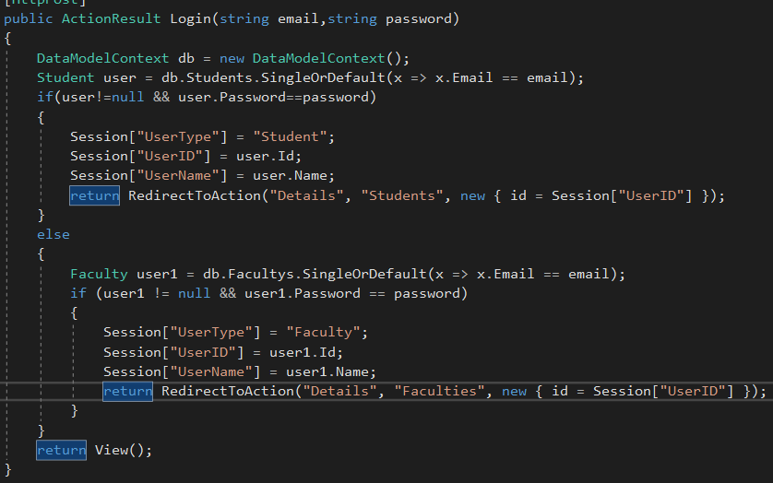

Fig 5.2.1

Register

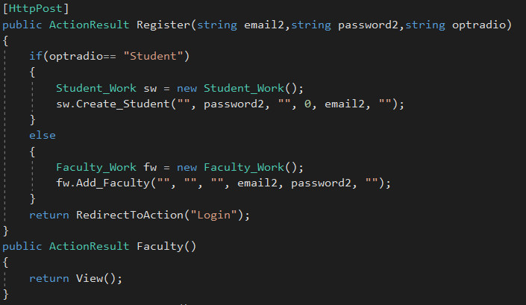

Fig 5.2.2

Add Question:-

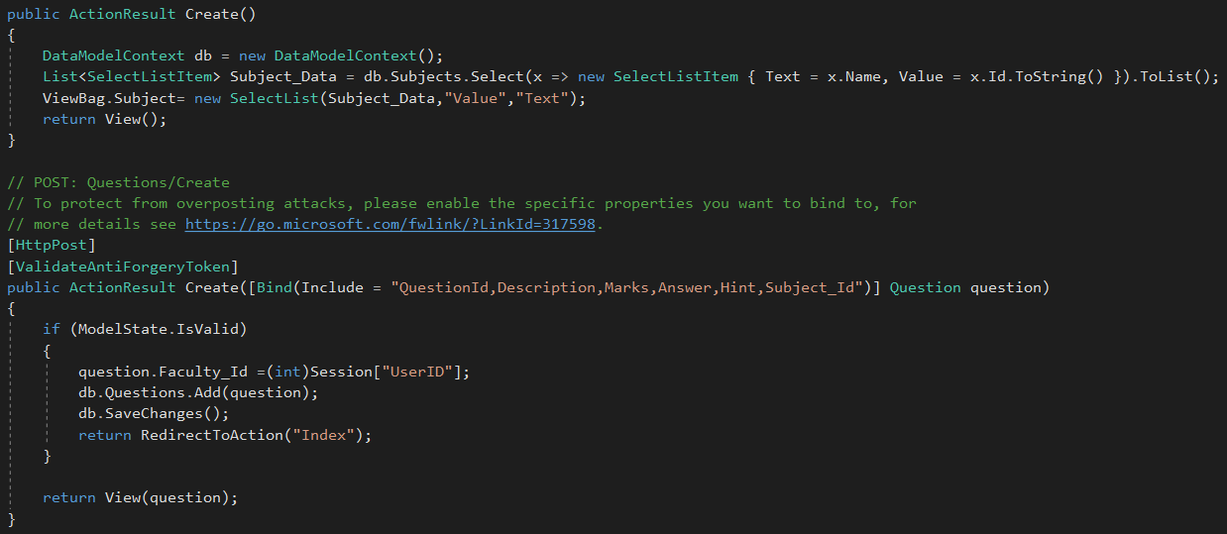

Add Paper:-

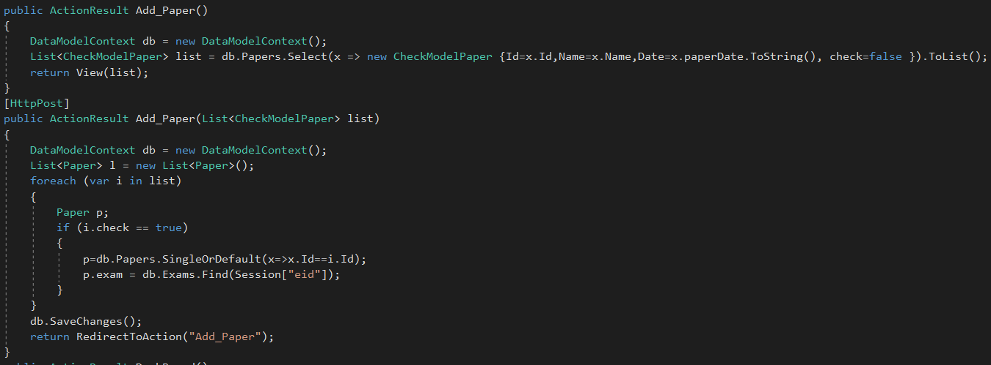

Add Exam:-

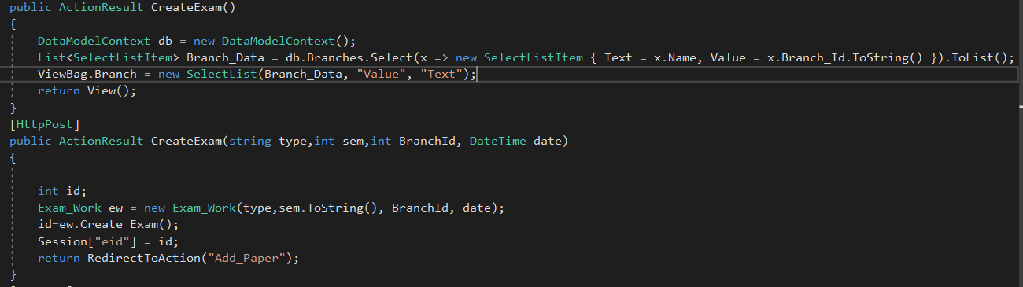

6. Testing

6.1: **Testing** **Methods**:

We have performed Black-box testing for the testing purpose.

7. Screenshot

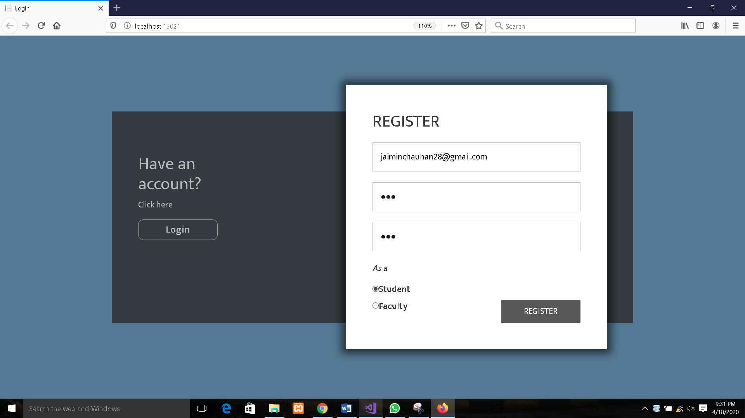

***Fig No:1. Register Page***

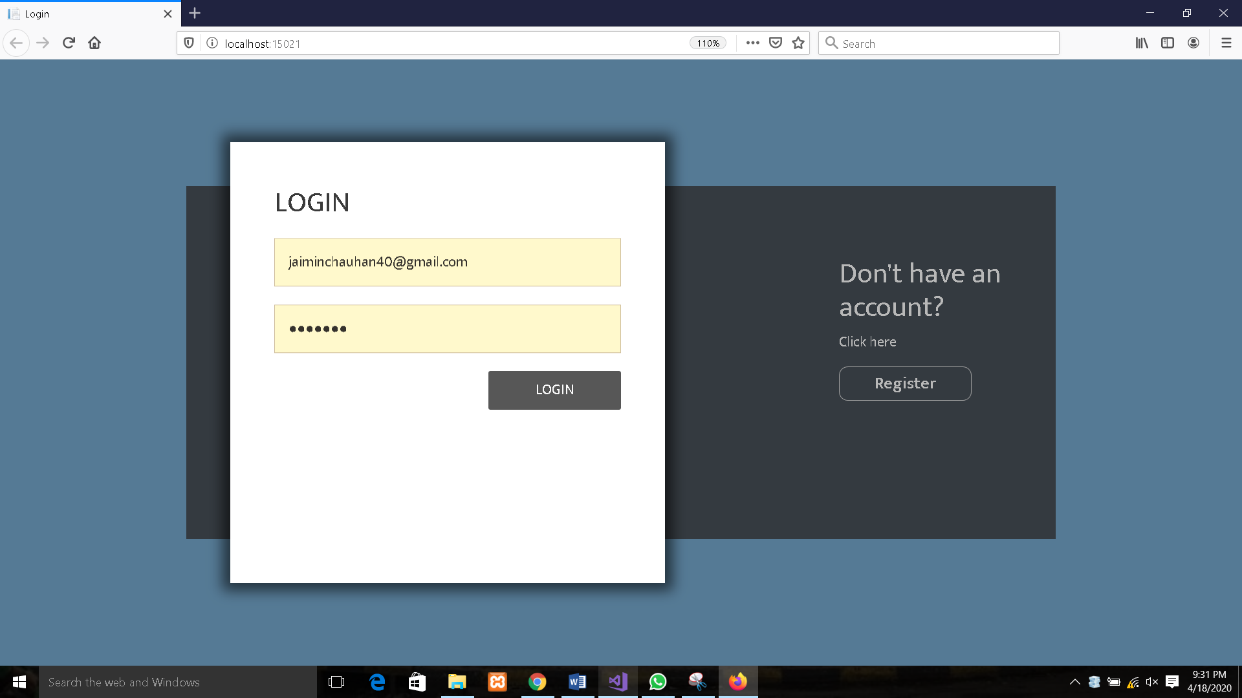

***Fig No:2. Login Page***

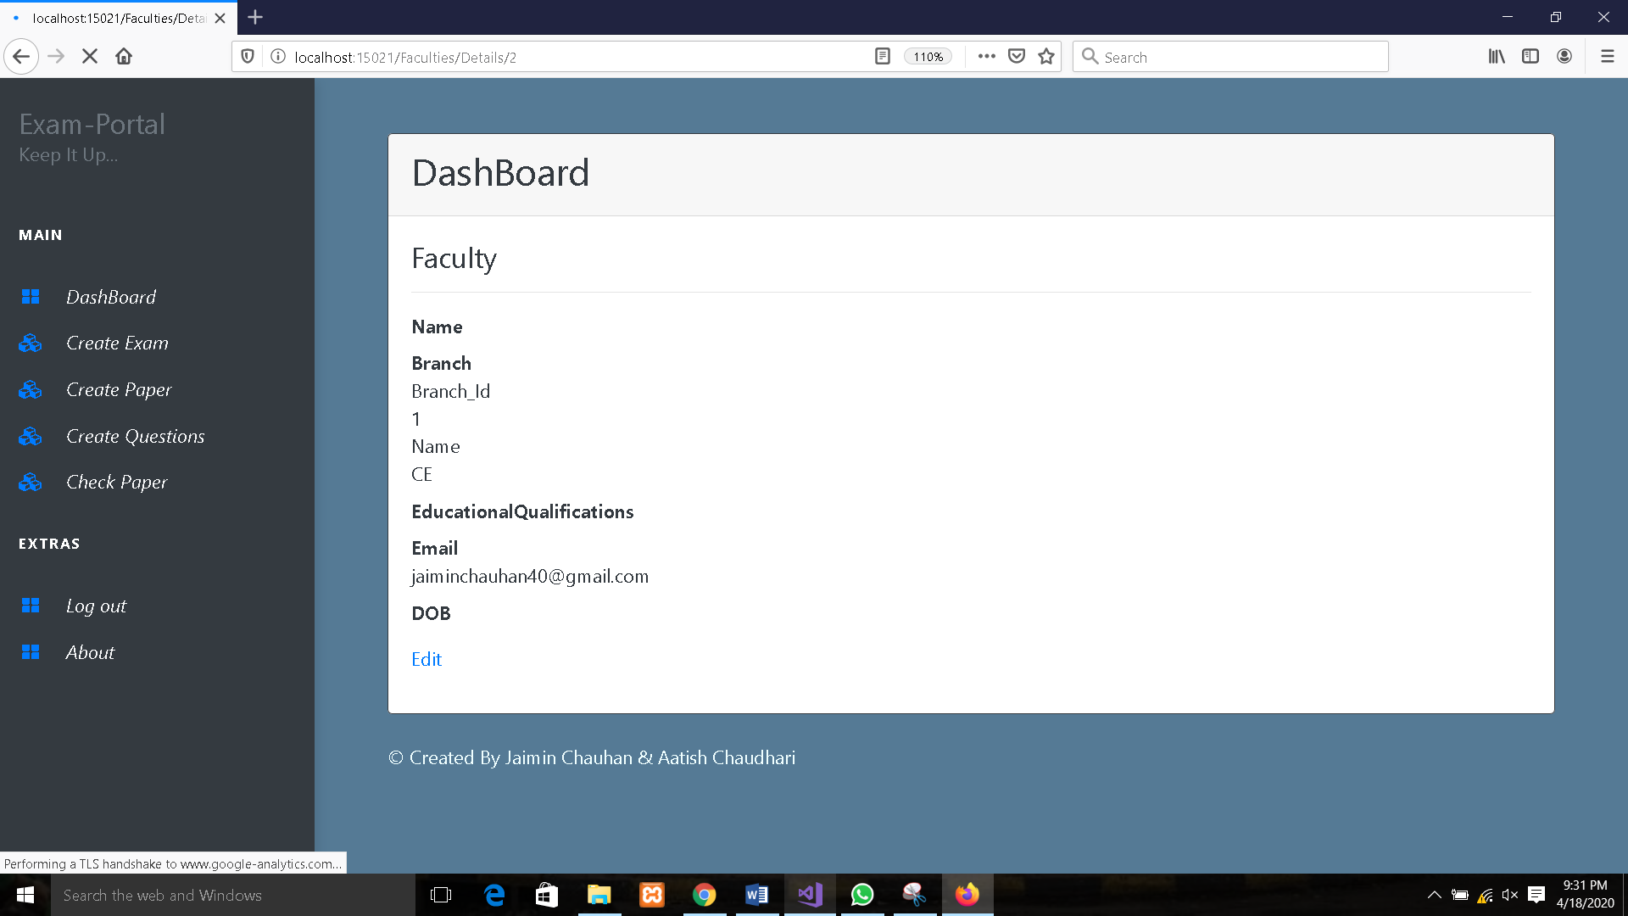

***Fig No:3.1 DashBoard of Faculty***

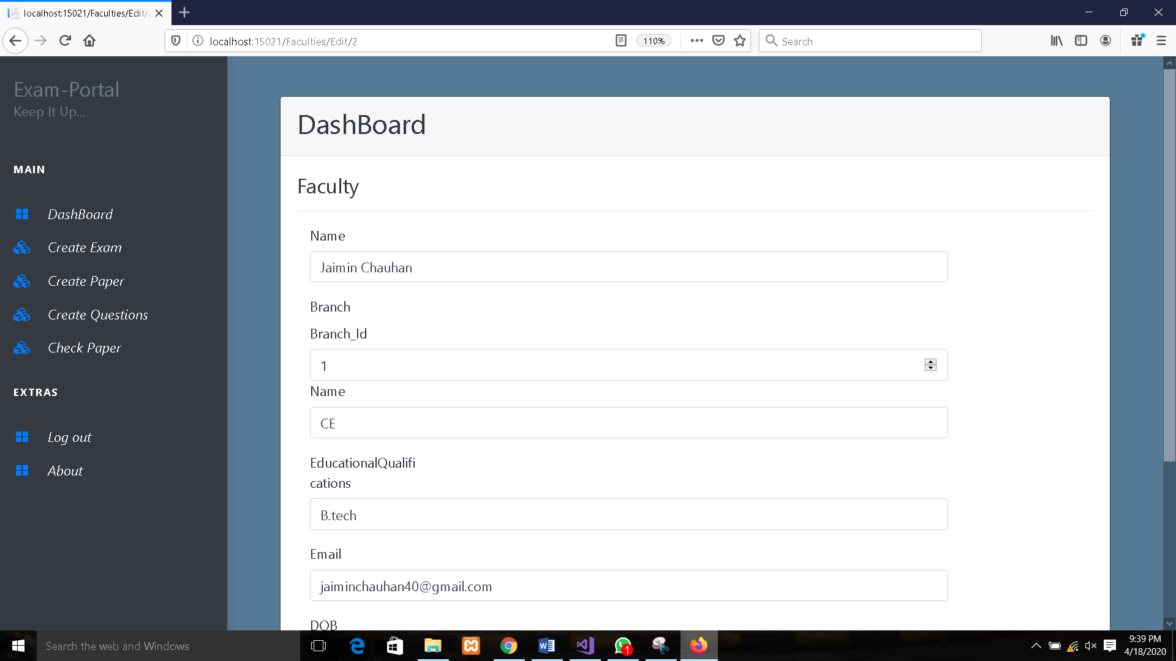

***Fig No:3.2 Edit Profile***

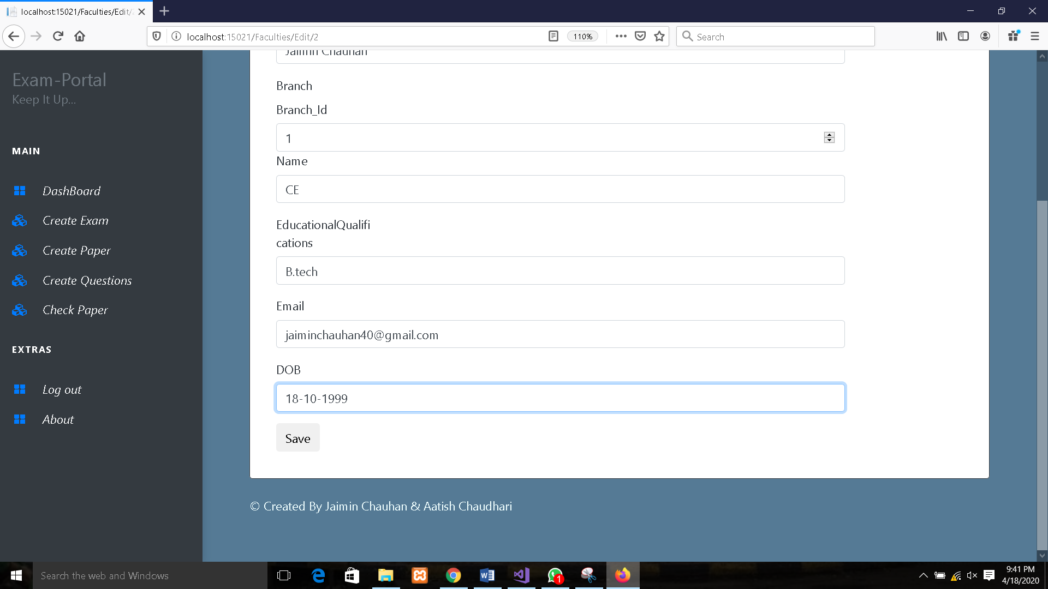

***Fig No:3.3 Edit Profile***

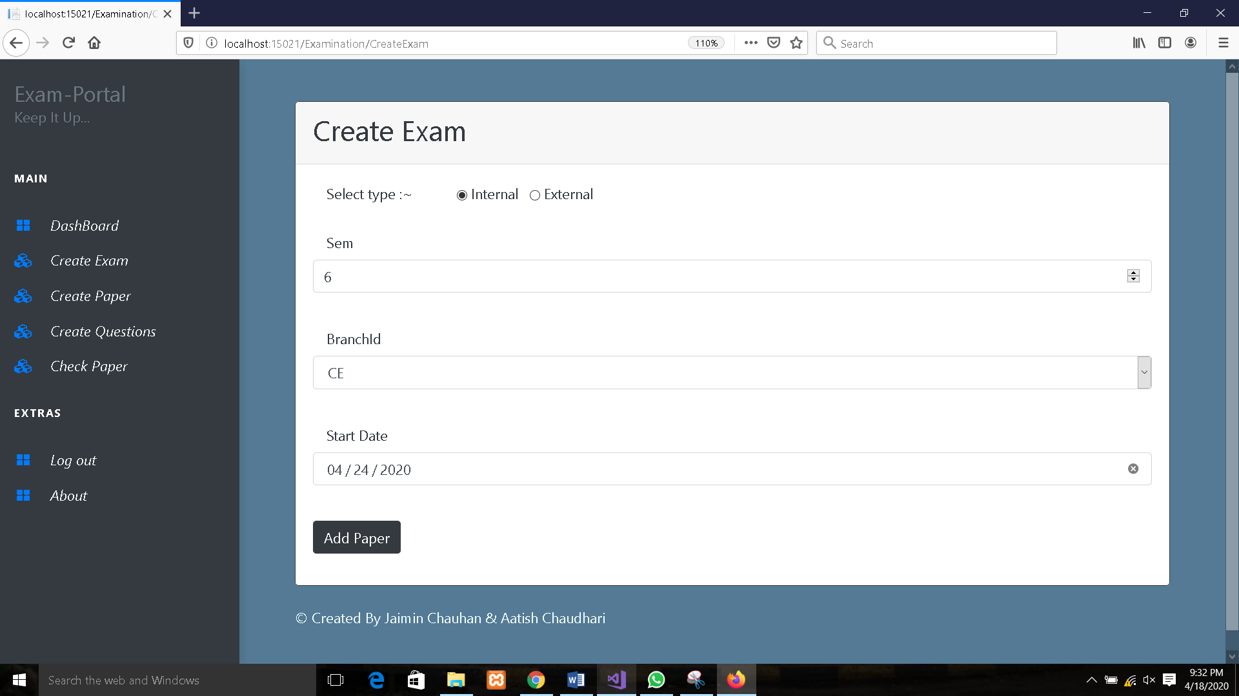

***Fig No:4 Create Exam***

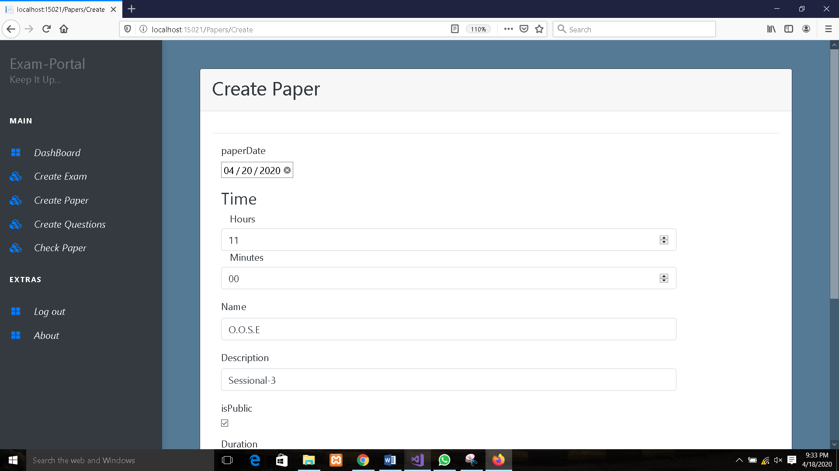

***Fig No:5.1 Create Paper***

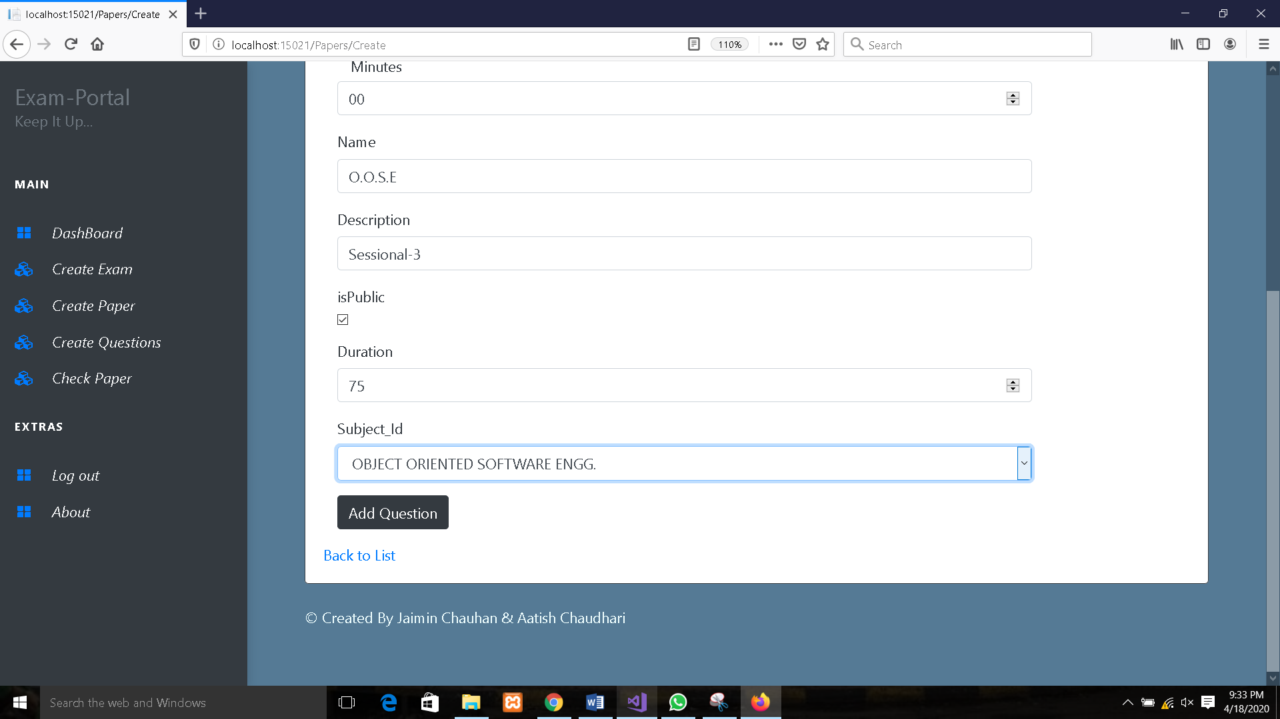

***Fig No:5.2 Create Paper***

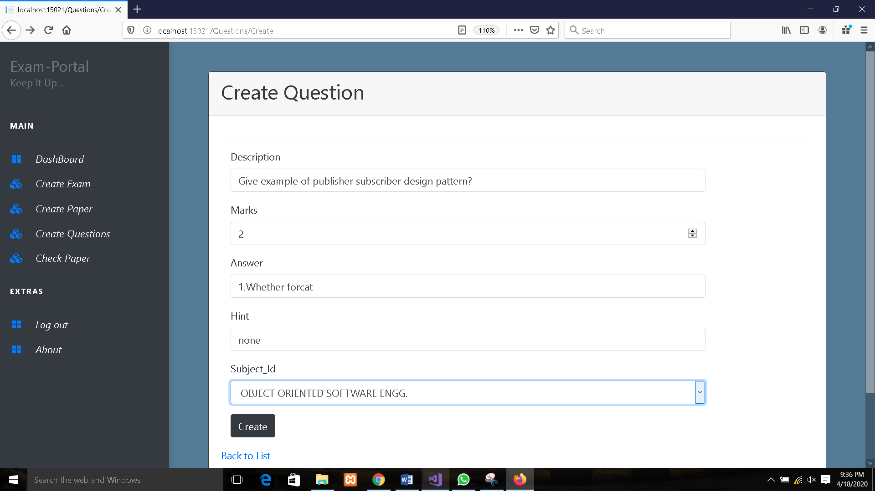

***Fig No:6 Create Question***

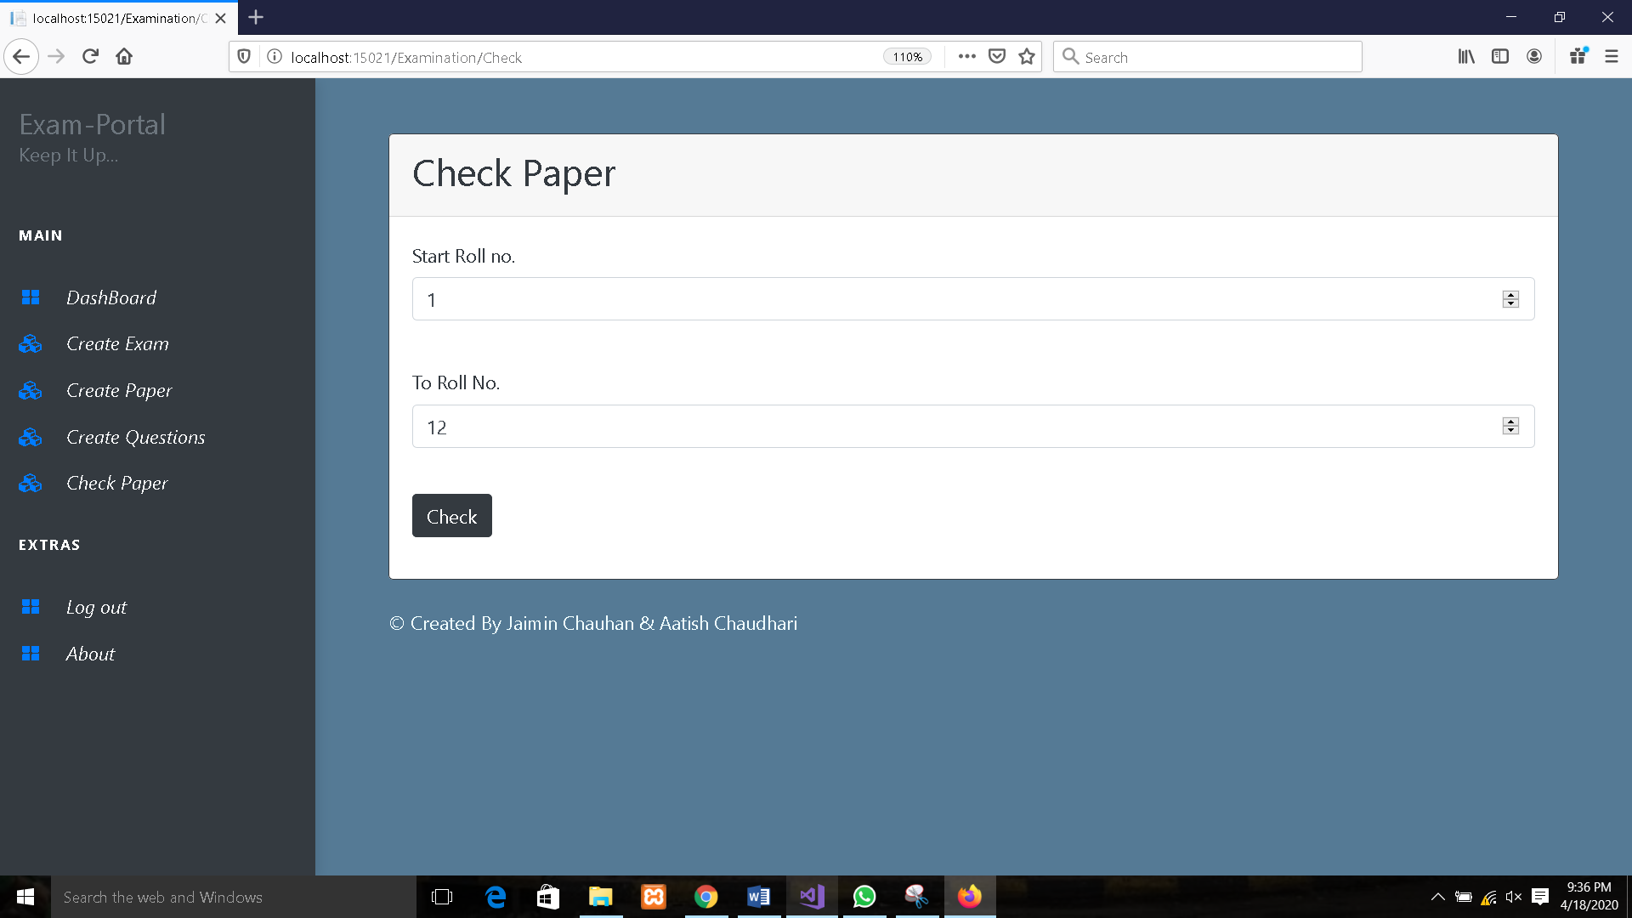

***Fig No:7.1 Check paper***

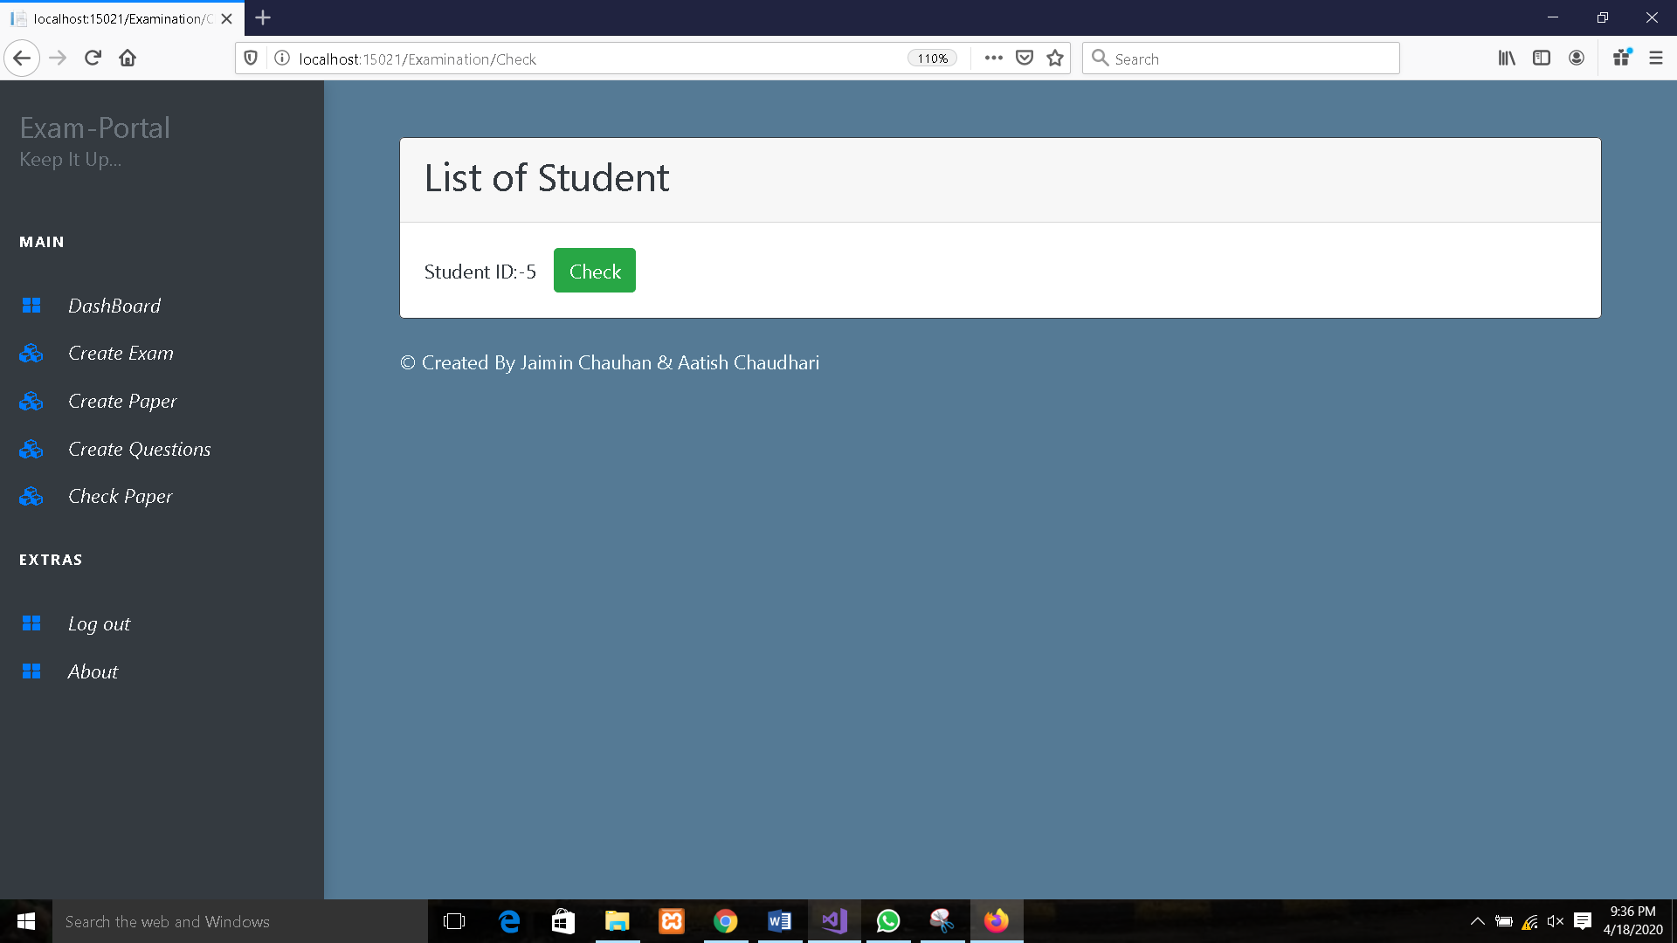

***Fig No:7.2 Check Paper***

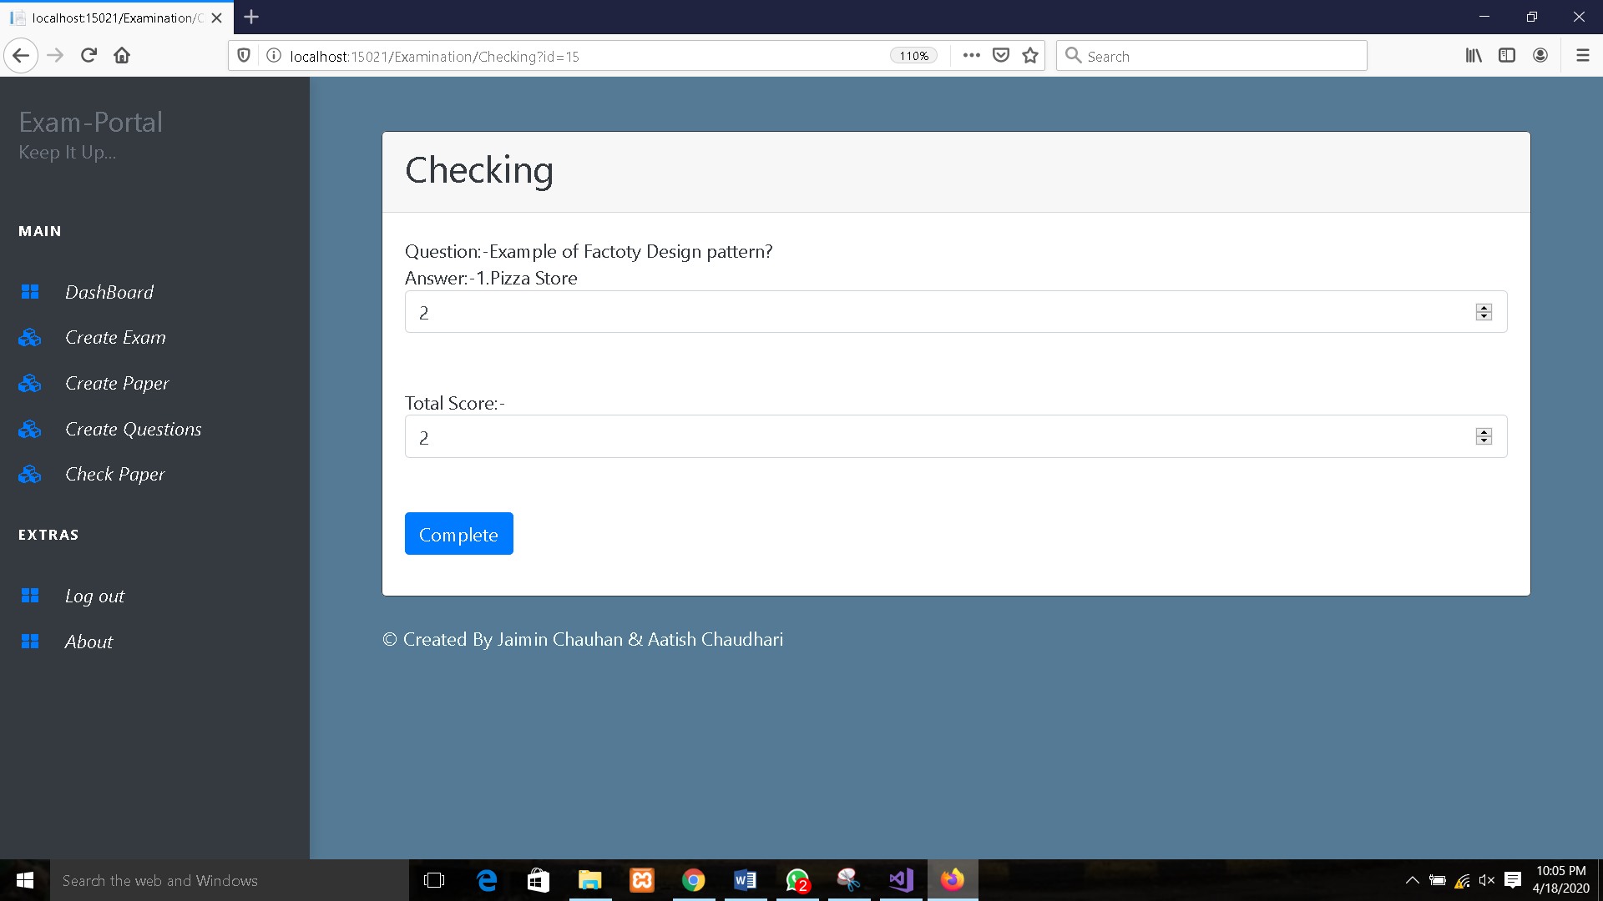

***Fig: No.7.3 Checking***

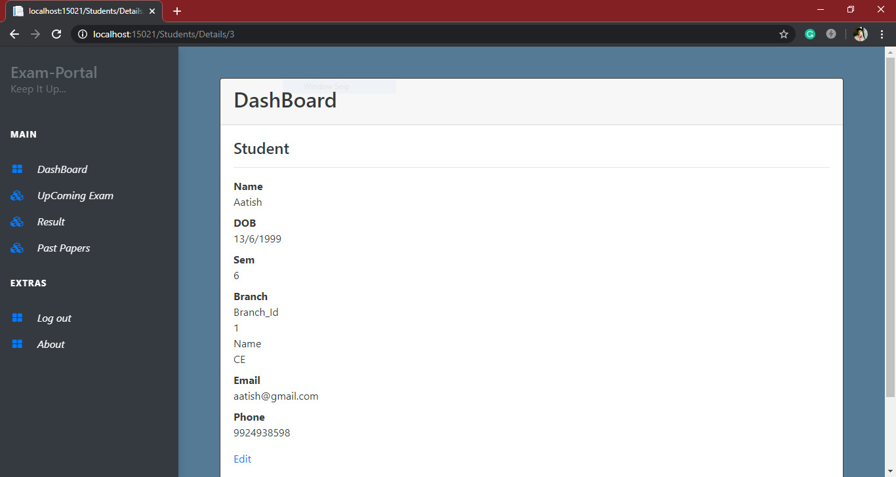

***Fig No:7.4 Student DashBoard***

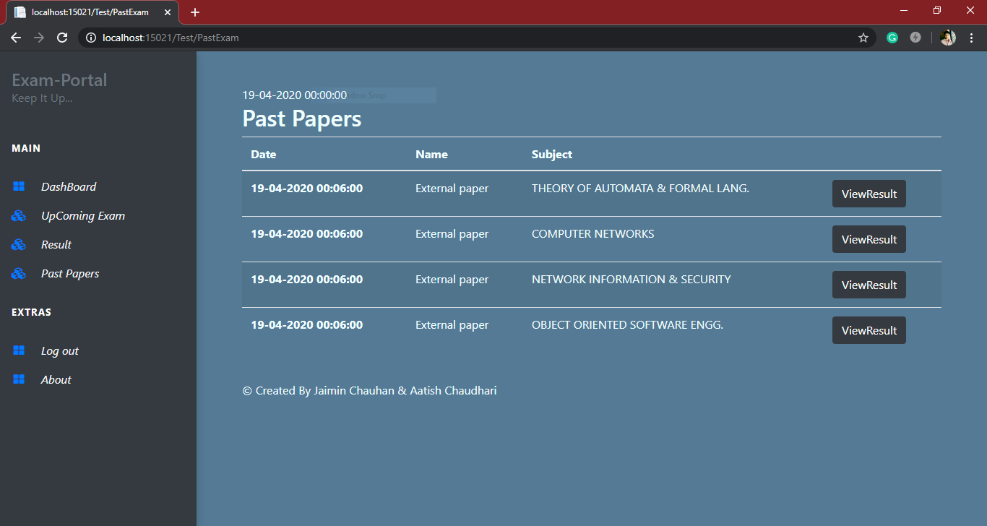

***Fig No:7.5 Past Papers***

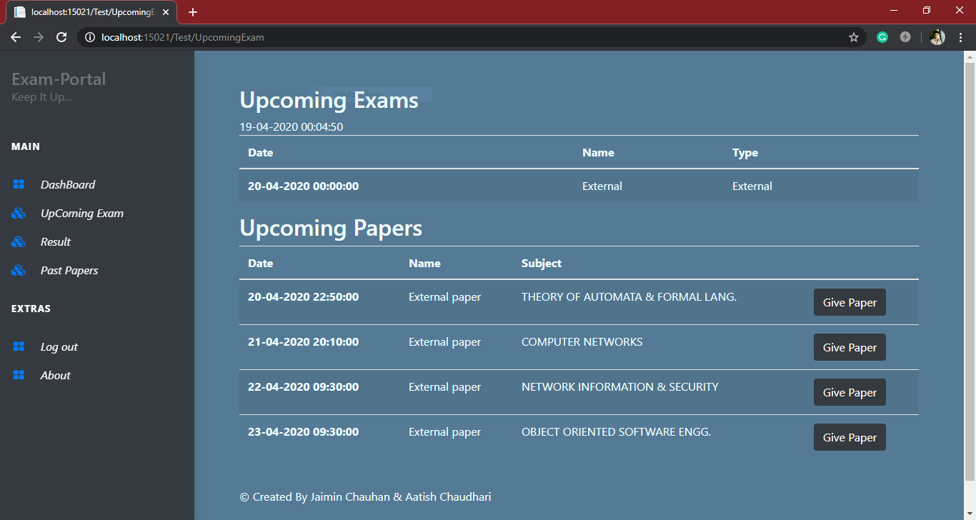

***Fig No:7.6 Upcoming Exams***

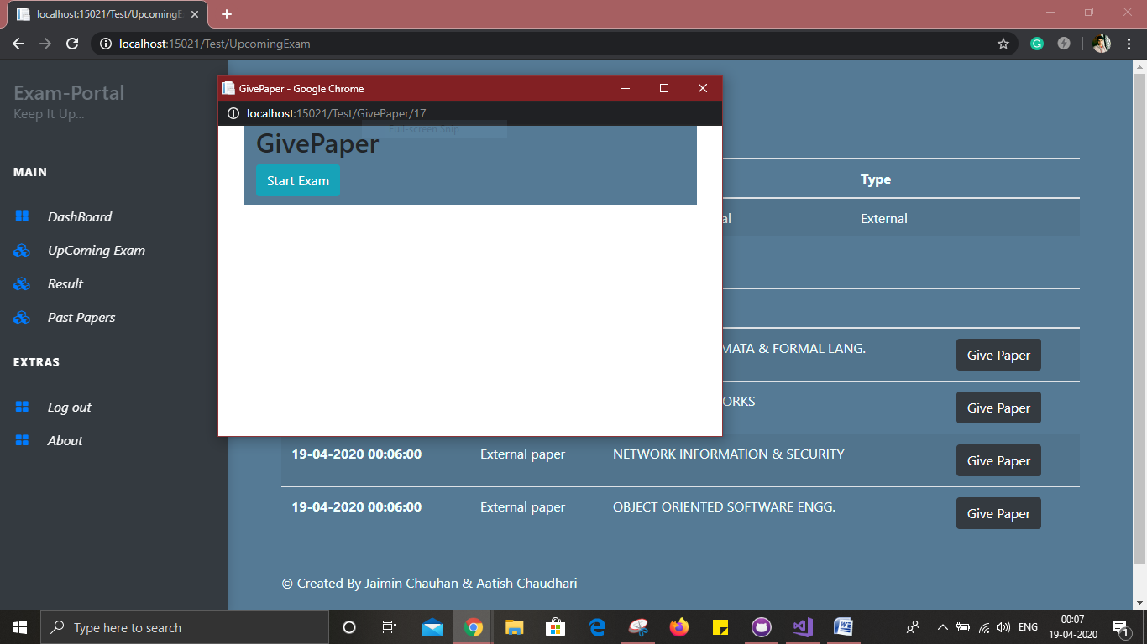

***Fig No:7.7 Test Console***

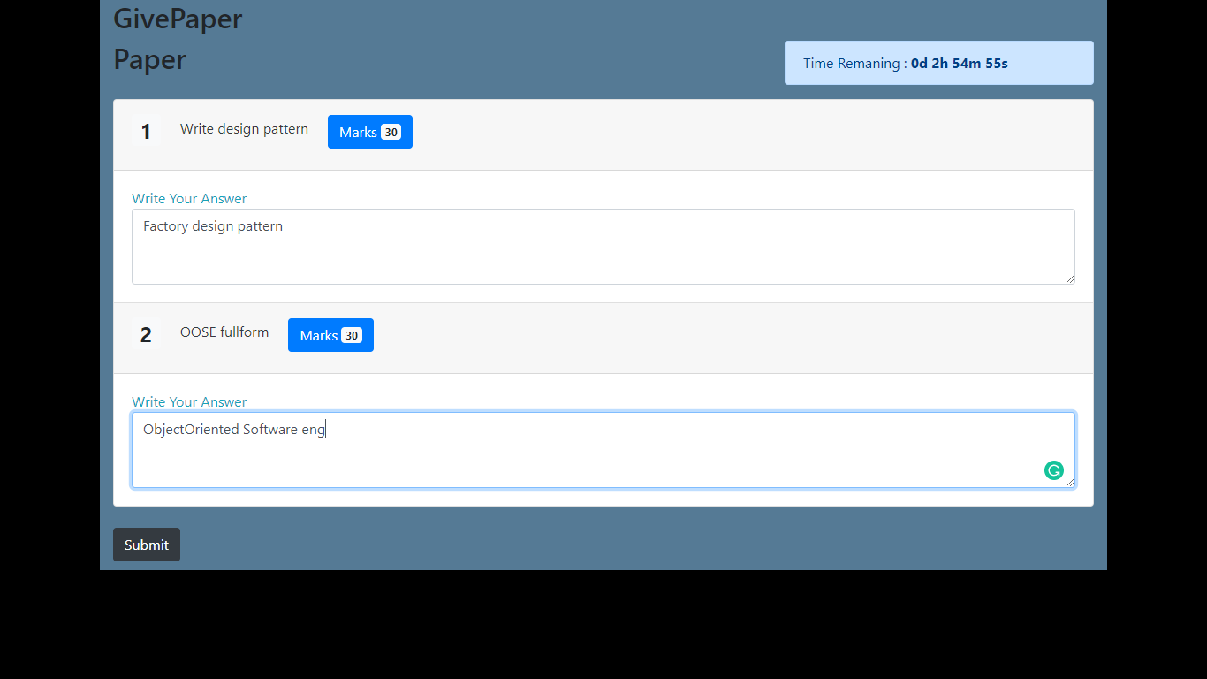

***Fig No:7.8 Test Stared***

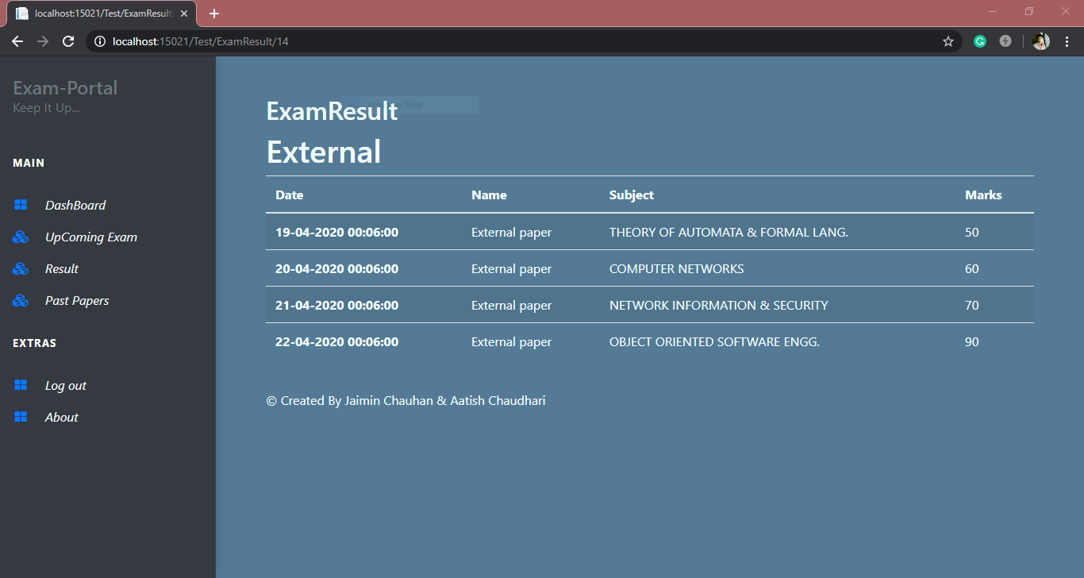

***Fig No:7.9 Result***

8. conclusion

The functionalities implemented in system after understanding all the system modules according to the requirements. Functionalities That are successfully implemented in the system are :

* User registration containing all the necessary validation on field
* login
* user authentication
* logout
* Question, Paper, Exam Upload
* Apply Exam
* Check Paper
* View Result
* View Schedule

After the implementation and coding of system comprehensive testing was performed on the system to determine the errors and possible flaws in the system.

9. Limitations and Future Enhancements

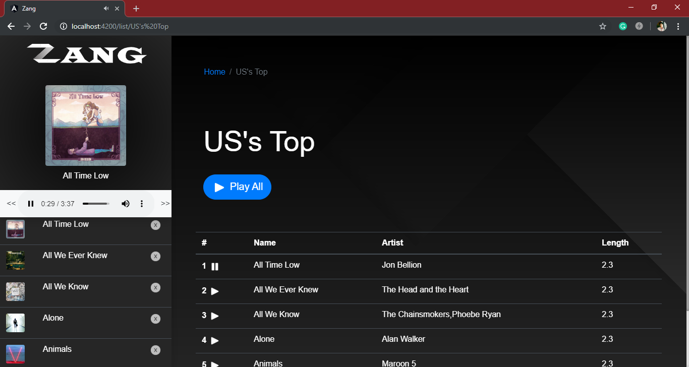The System has adequate scope for modification in future if it is necessary.

Development and launching of Mobile app and refining existing services and adding more service, System security, data security and reliability are the main feature.

In the existing system we try to improve reliability and robustness of a system in future scope.

10. Reference / Bibliography

Following links and websites were referred during the development of this project.

<https://www.google.co.in>

<http://www.wikipedia.org>

<http://www.getbootstrap.com>

<http://www.tutorialspoint.com>

<http://www.stackoverflow.com>